**Step 1: Log in to the Azure Portal**

⦁ Open your web browser and go to the [Azure Portal](https://portal.azure.com)

⦁ Log in with your Azure credentials.

**Step 2: To create a Virtual Machine Service**

⦁ Choose “**Virtual Machines**” from the column in the page after heading.

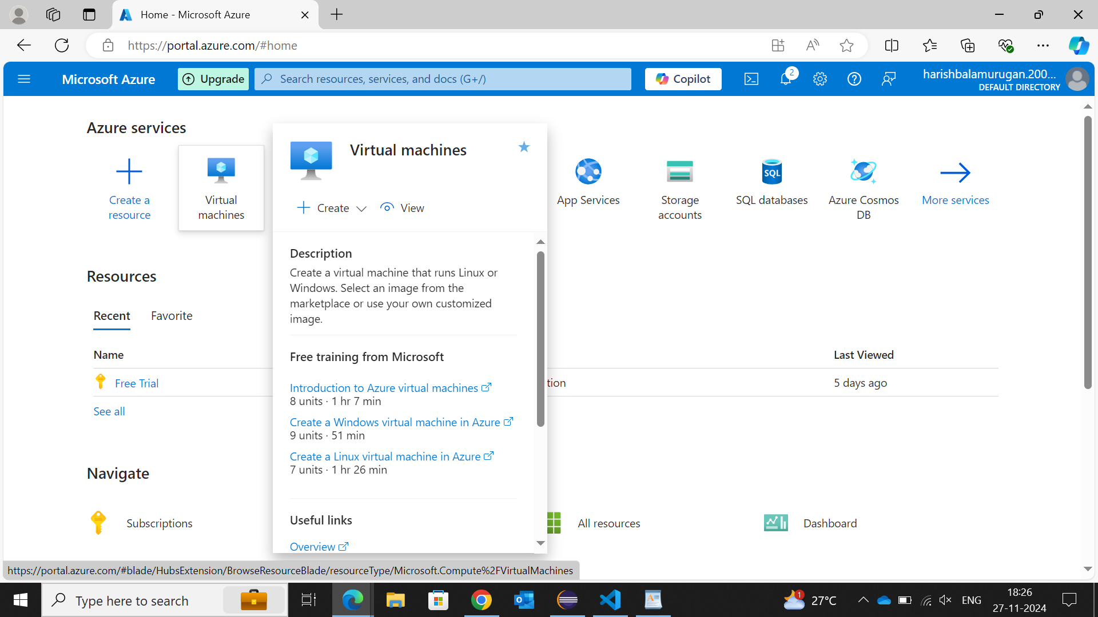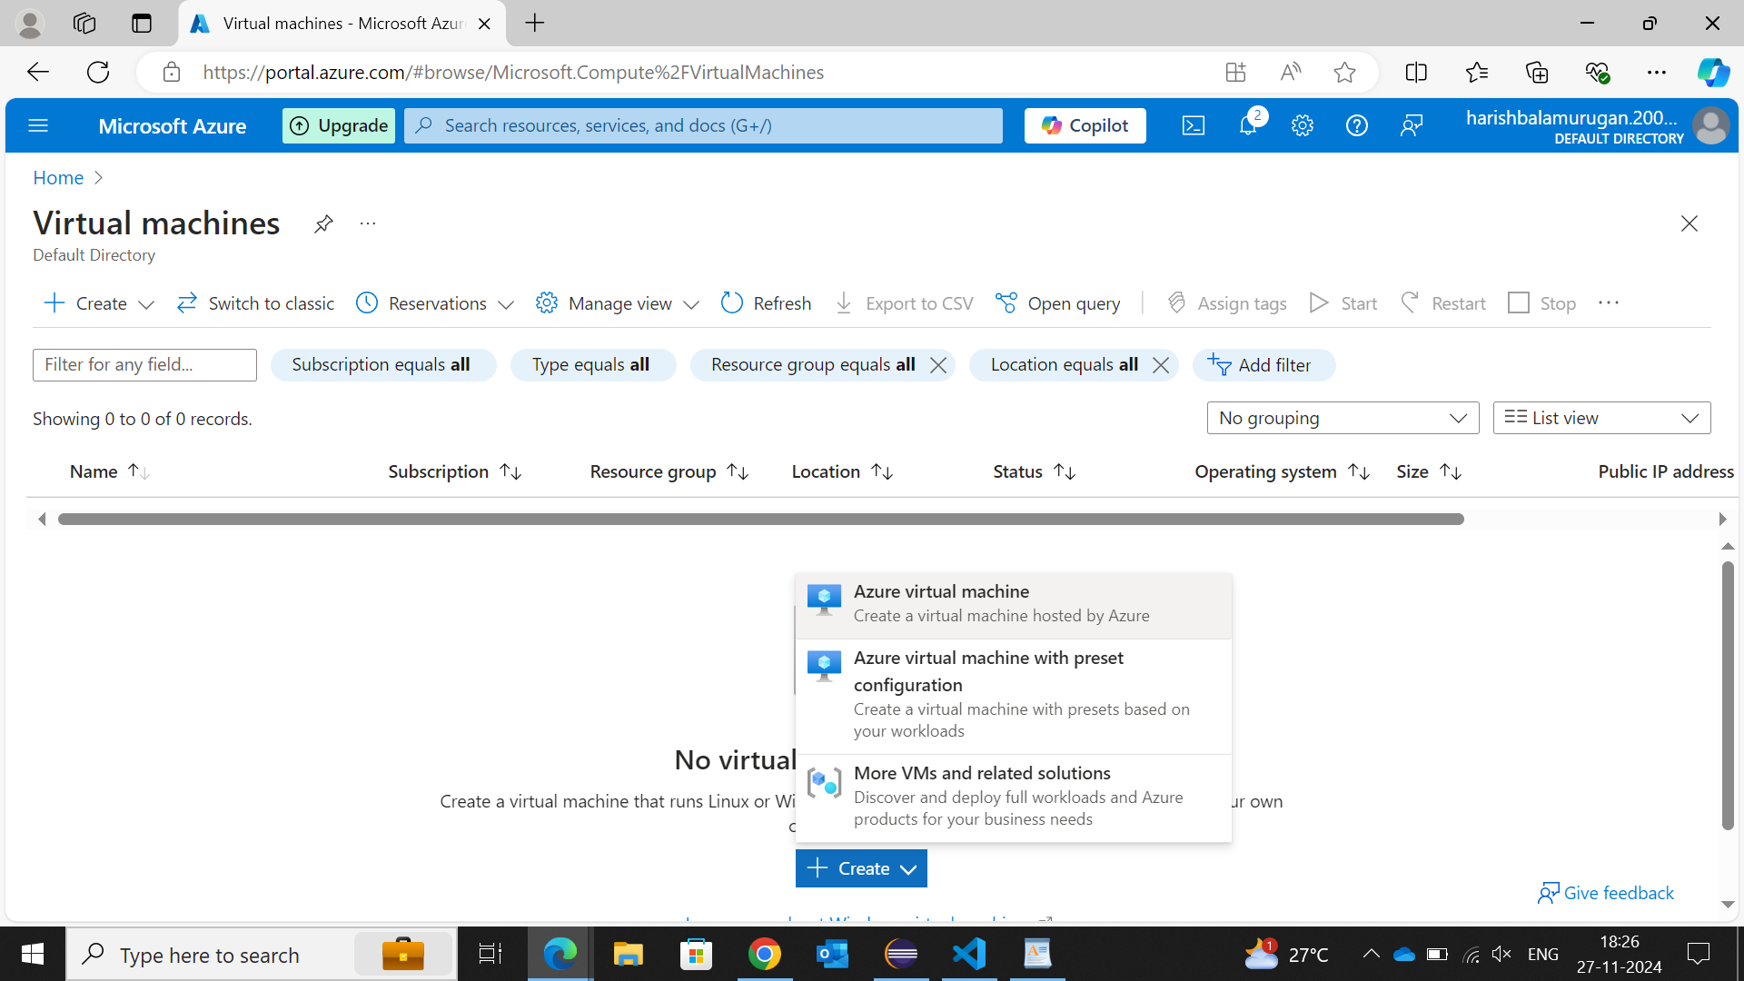

**Step 3: Create a New Virtual Machine**

⦁ Click the "Create" button and choose "Virtual machine" to start the creation process.

⦁ You'll be directed to the "Create a virtual machine" page.

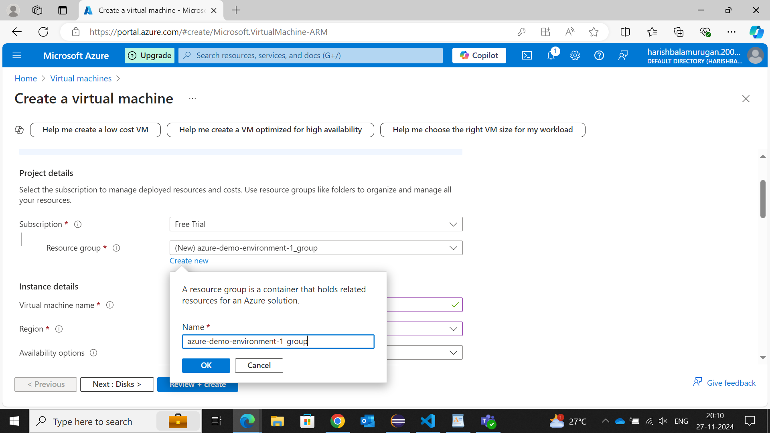

**Step 4: Configure Basic Settings**

* **Subscription:** Select the subscription if you’re a free trial user select Free Trial.
* **Resource Group:** Choose an existing resource group or click "Create new" to create a new one.
* **Virtual Machine Name:** Enter a name for your VM (e.g., "azure-demo-environment-1").
* **Region:** Select the Azure region where you want to host your VM. Select nearby of your country like South India.
* **Availability Options:** Choose if you want high availability using Availability sets or Zones otherwise leave it.
* **Image:** Select the operating system **Image** you want for the VM (e.g., Windows Server, Ubuntu. Choose Windows Server).
* **Security Type:** Select **Standard** from the option listed below.
* After that for a list of options until username and password leave as it is until you are a new to Azure you don’t need to take care of that.
* Administrator Account: Create a username and password credentials for the VM you’ve created.

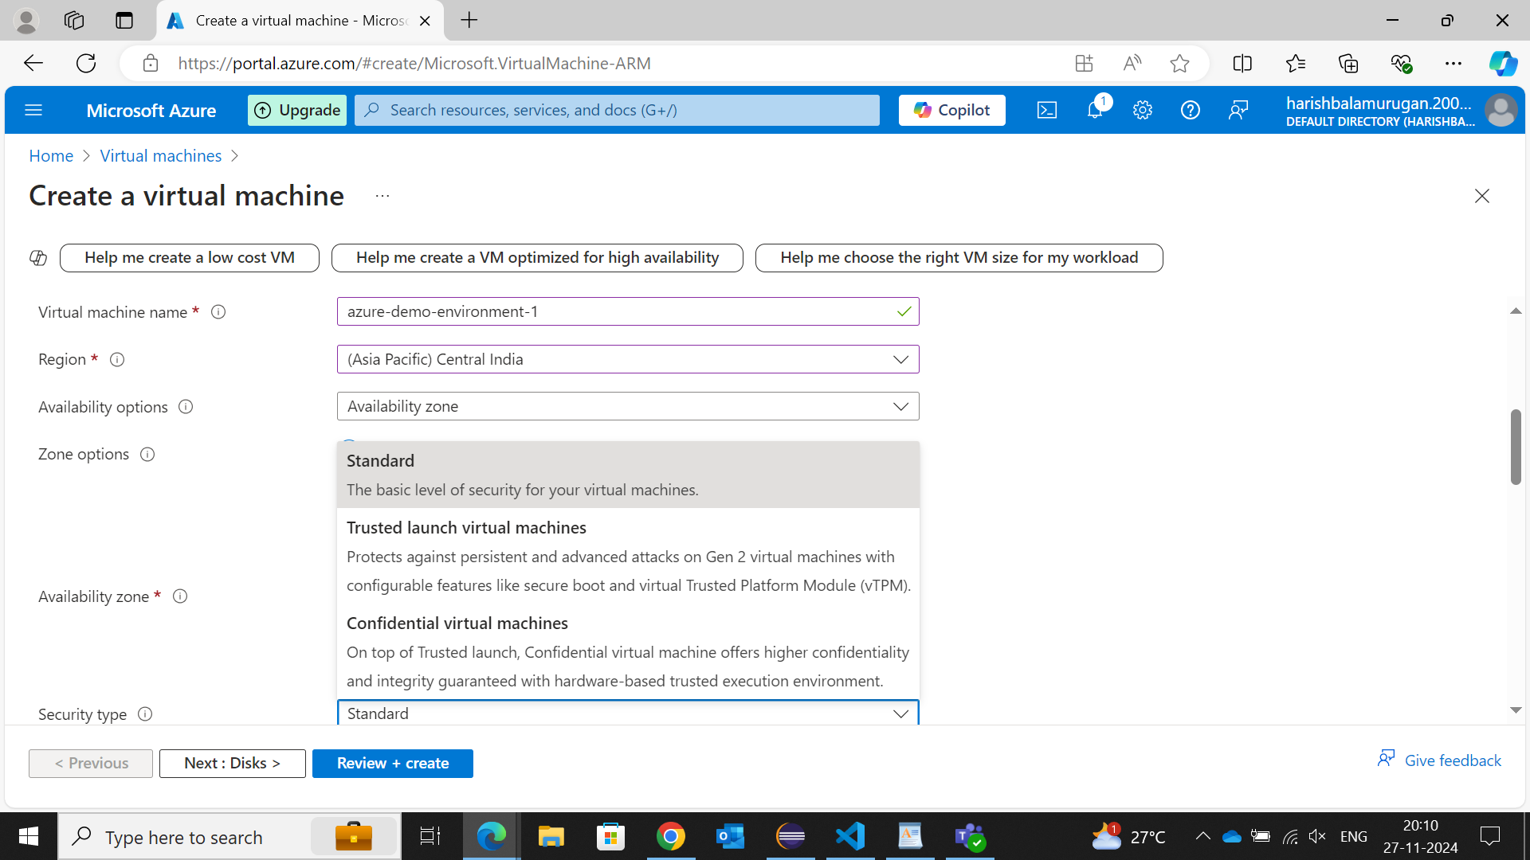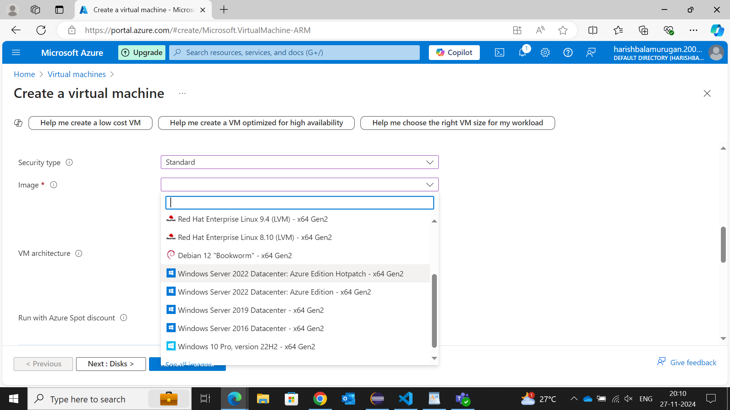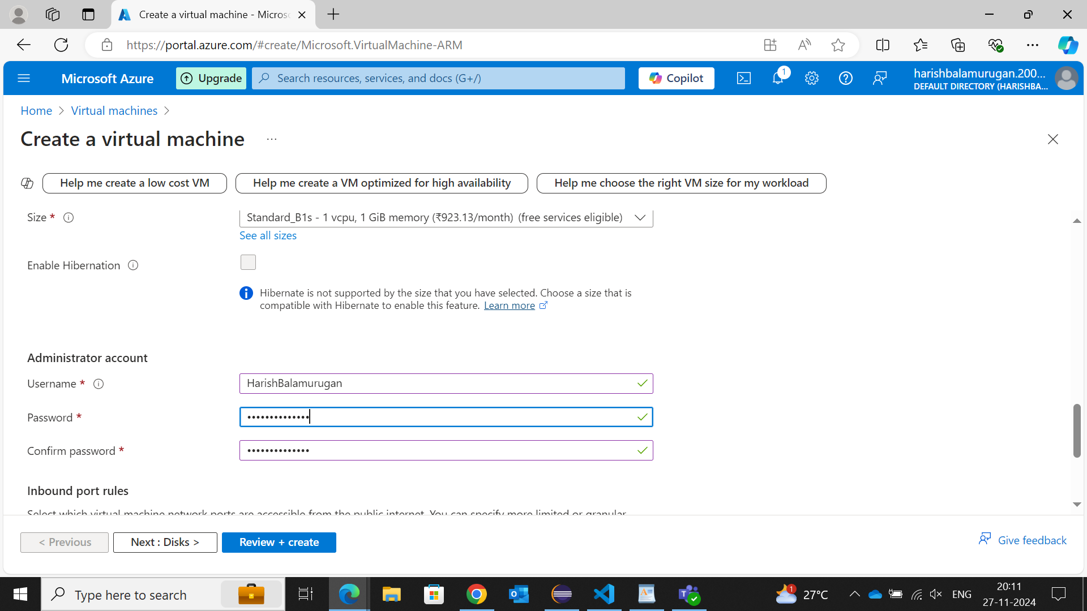

**Step 5: Review and Create**

⦁ Click the "Review + create" button.

⦁ Azure will validate the configuration. If everything is correct, you’ll see a green check mark and you can also see your basic requirements, size of VM and Networking in that window.

⦁ Review the settings and click "**Create**" to start the server deployment.

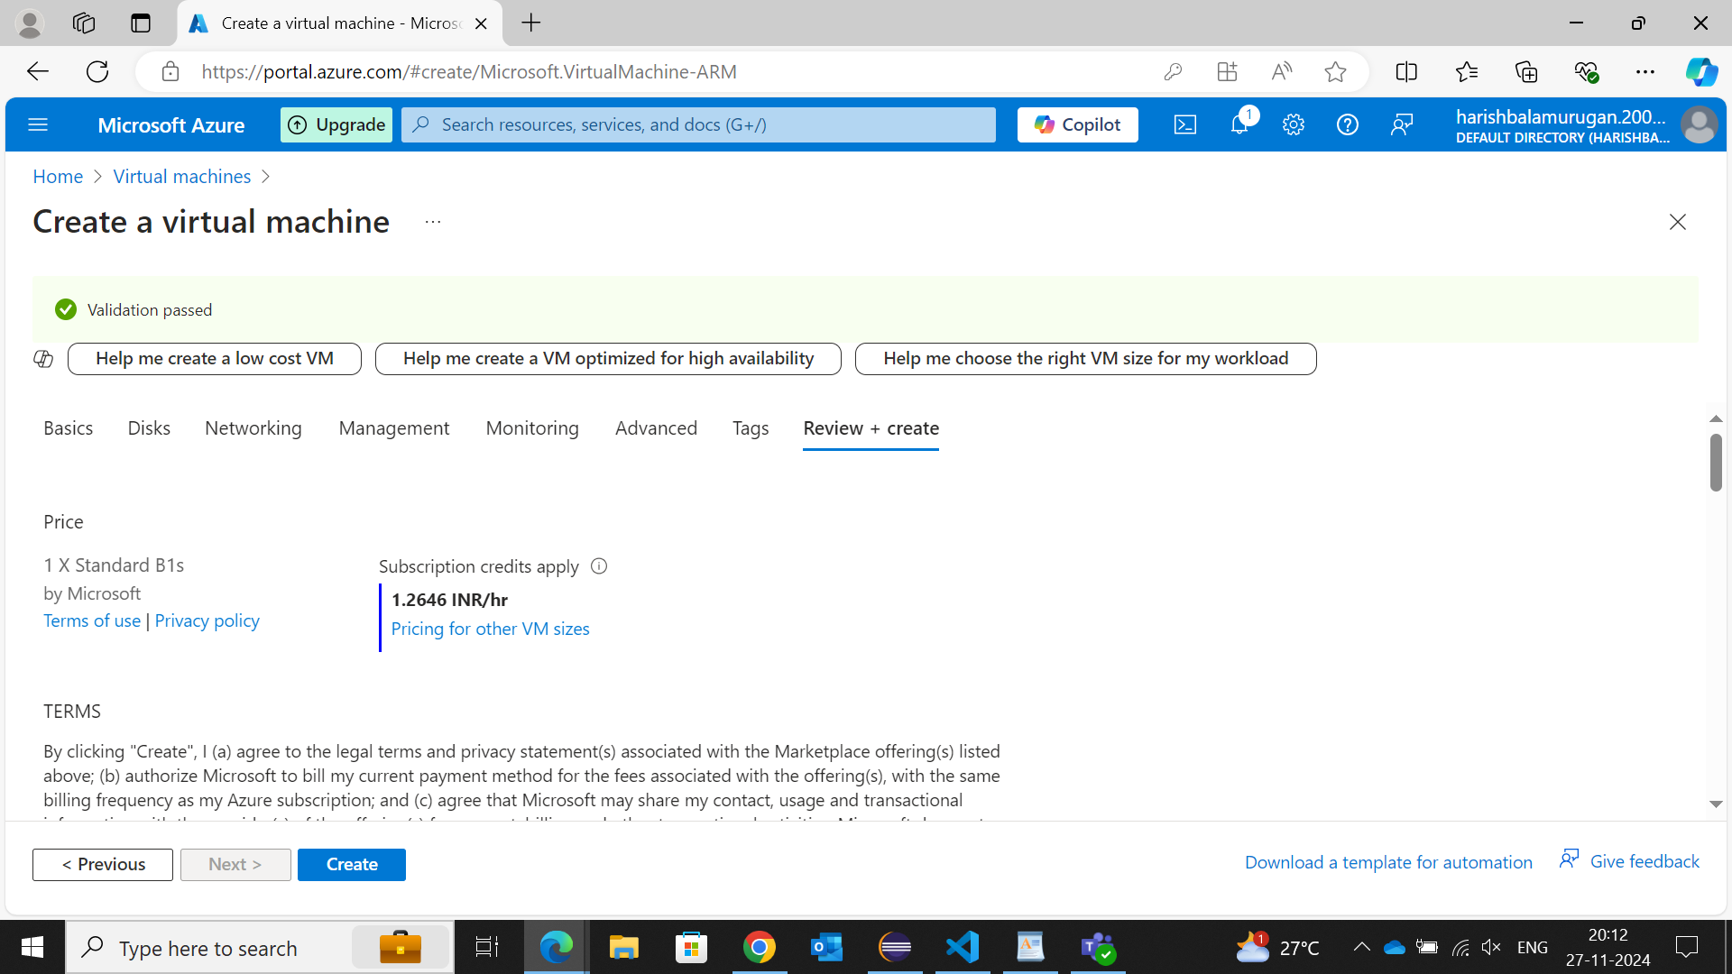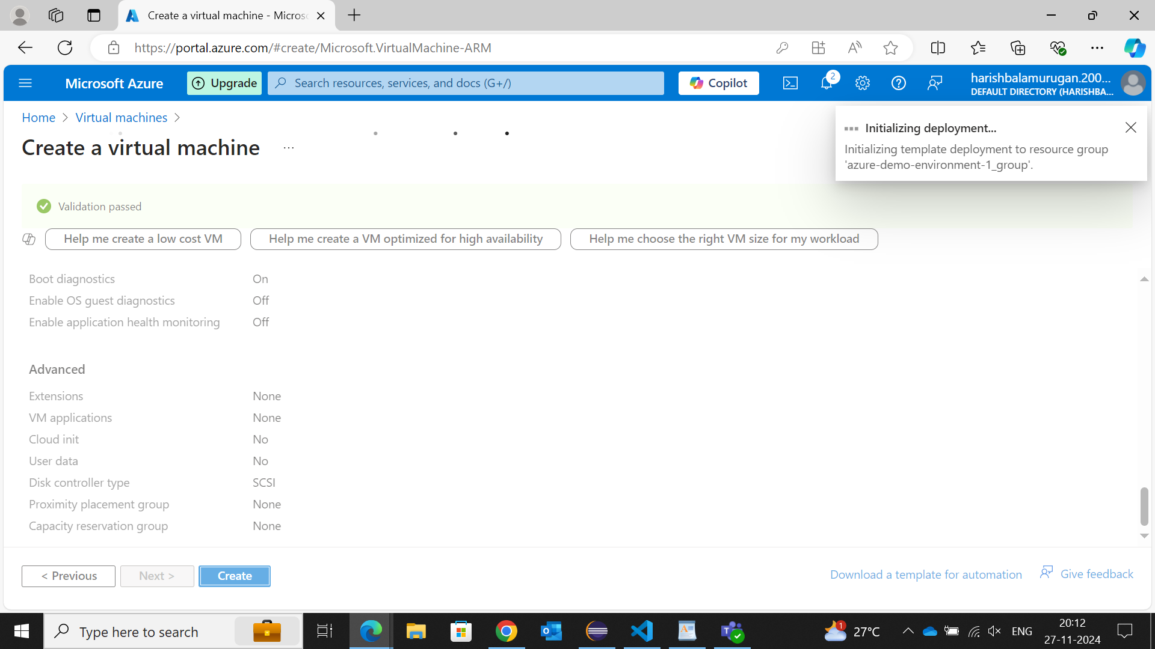

**Step 6: Deployment and Access**

⦁ Azure will begin the deployment, and you'll see the status as “Deployment in Progress”.

⦁ Once the VM is created, you will see " Your deployment is complete " go to the "**Home -> Virtual Machines**" or "**Home -> Resources -> Recent** " section in the Azure Portal.

⦁ Click on your VM to view details. You can get the Public IP Address from the Overview page.

⦁ Use the Public IP Address to connect to the VM, if you’re using Windows check for Hyper-V Manager in your Windows Administrative Tools or else go to your PowerShell type command **systeminfo** if Hyper-V for four options is available you can run your VM in your machine.

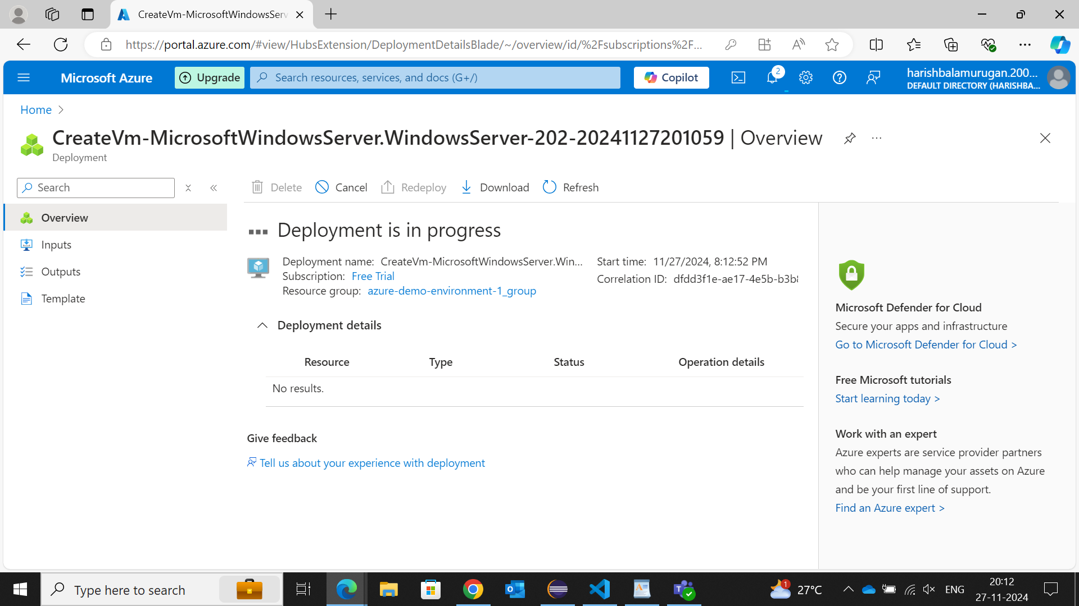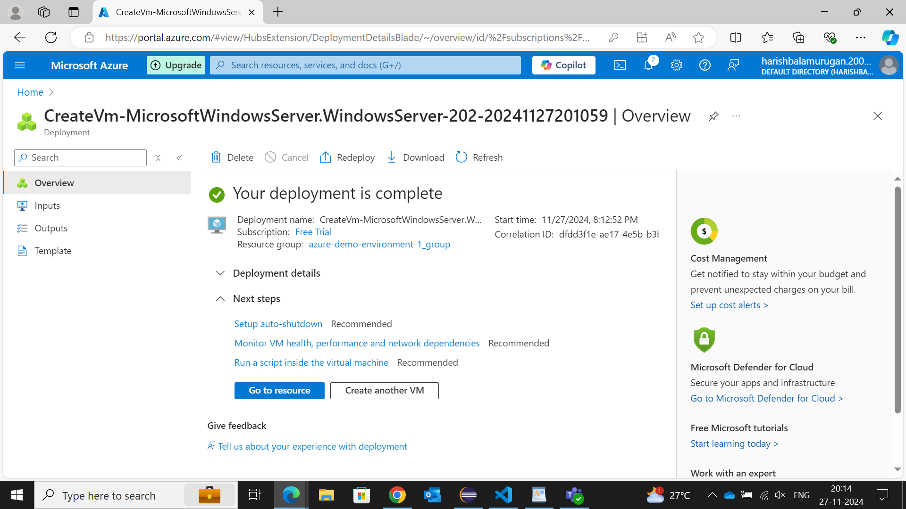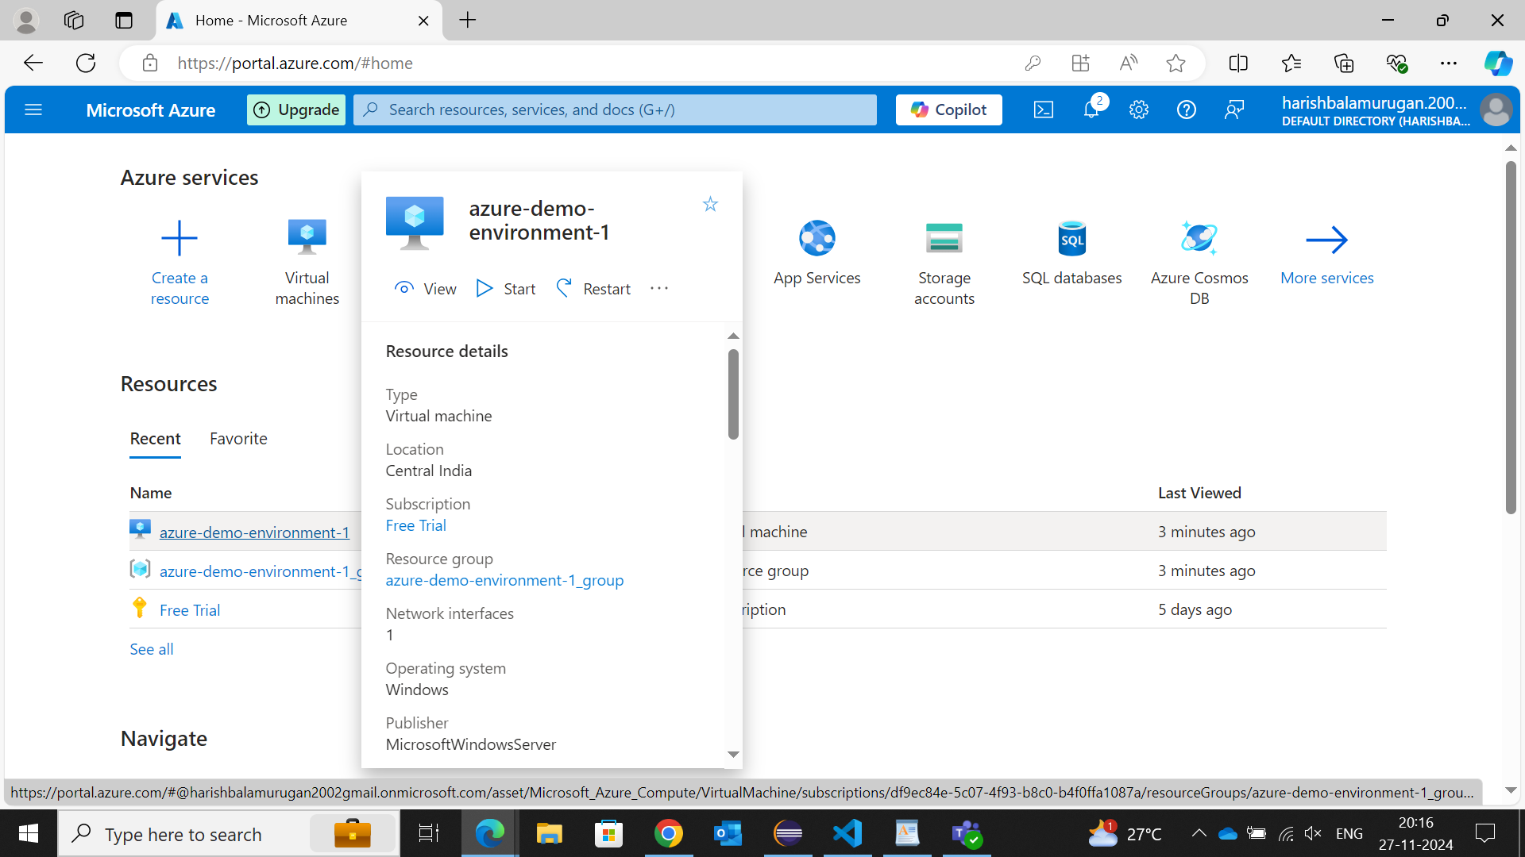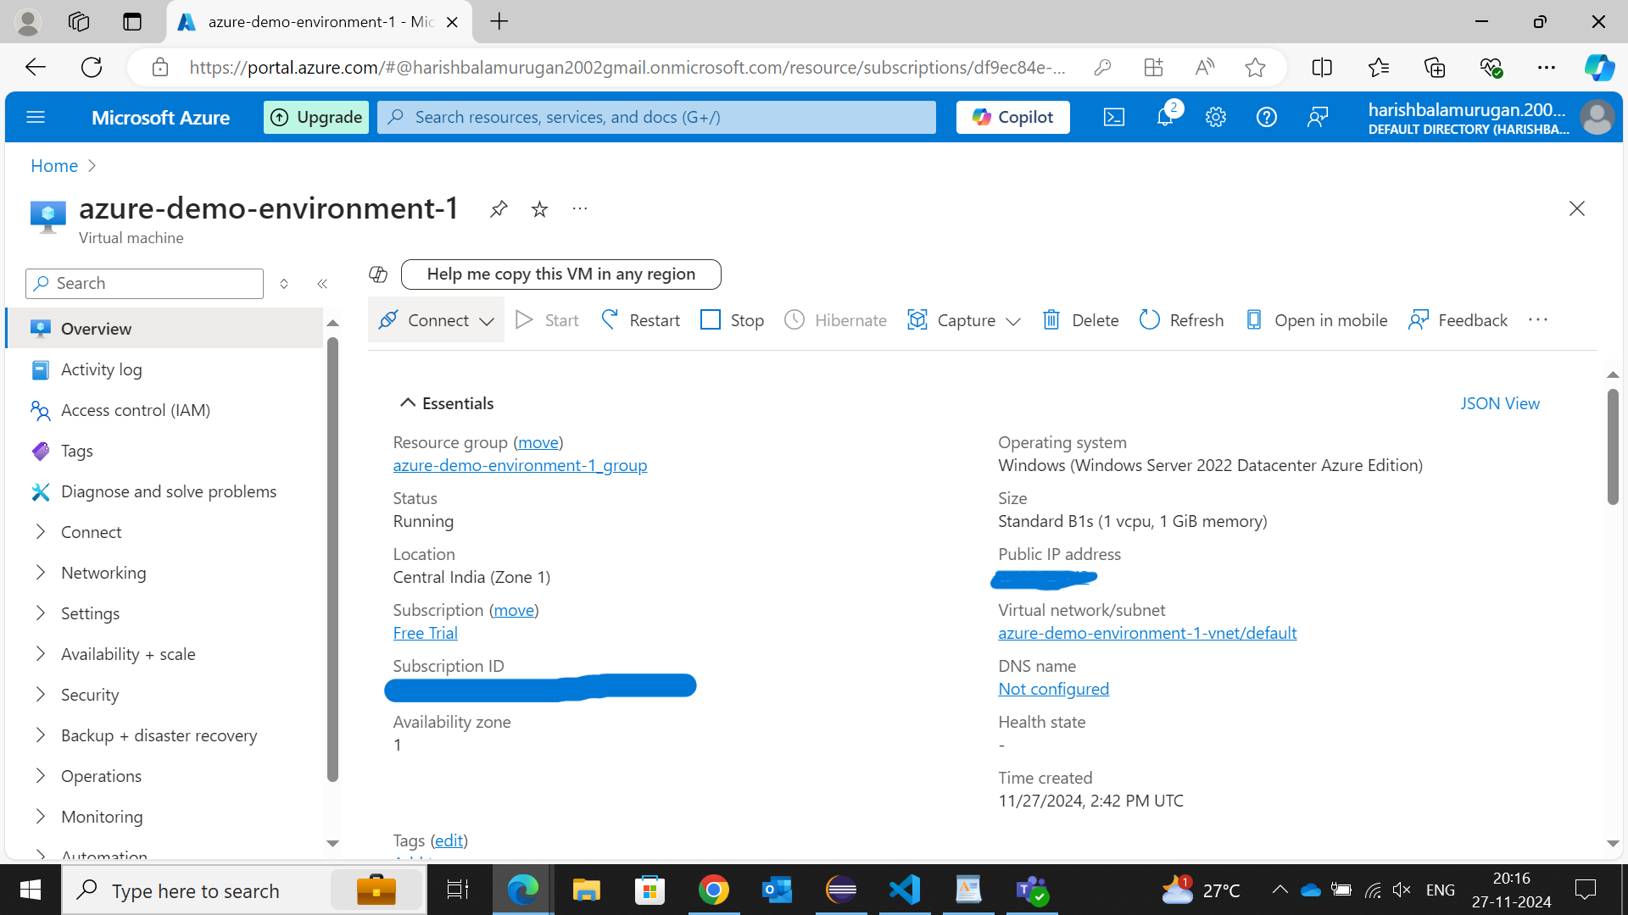

**Step 7: Virtual Machine Created.**

Scroll down and select **Download RDP** file and run that file with the credentials that you’ve entered while the creation of the VM.

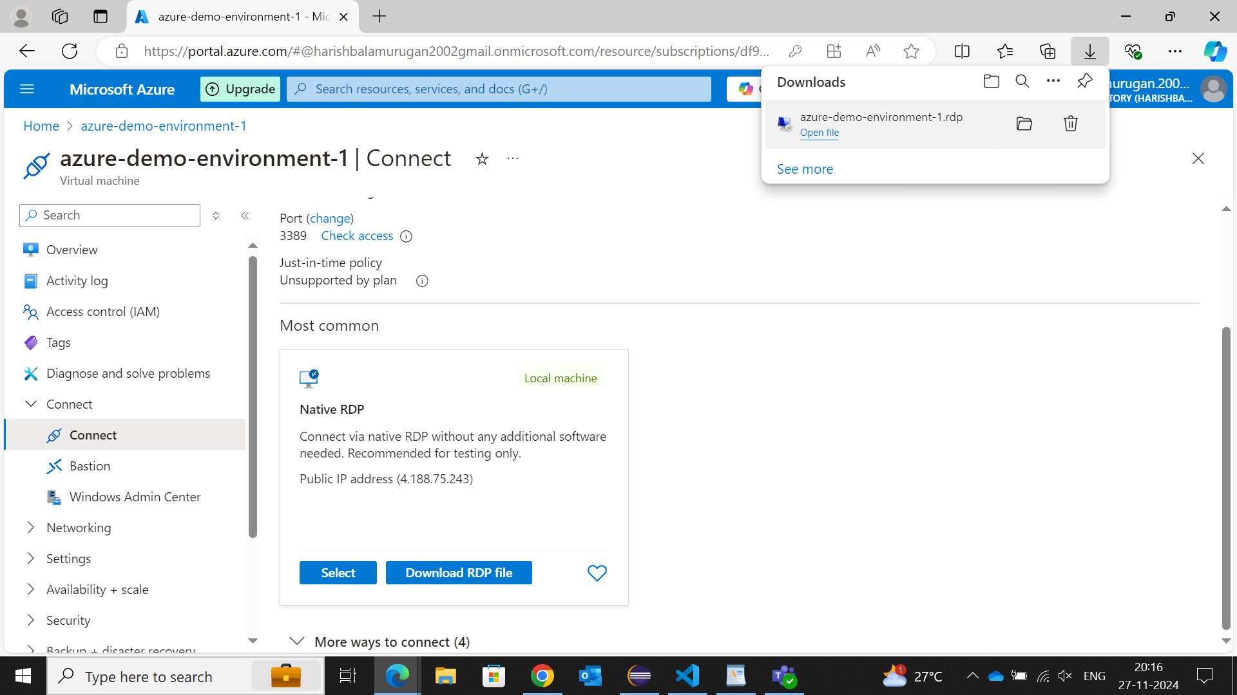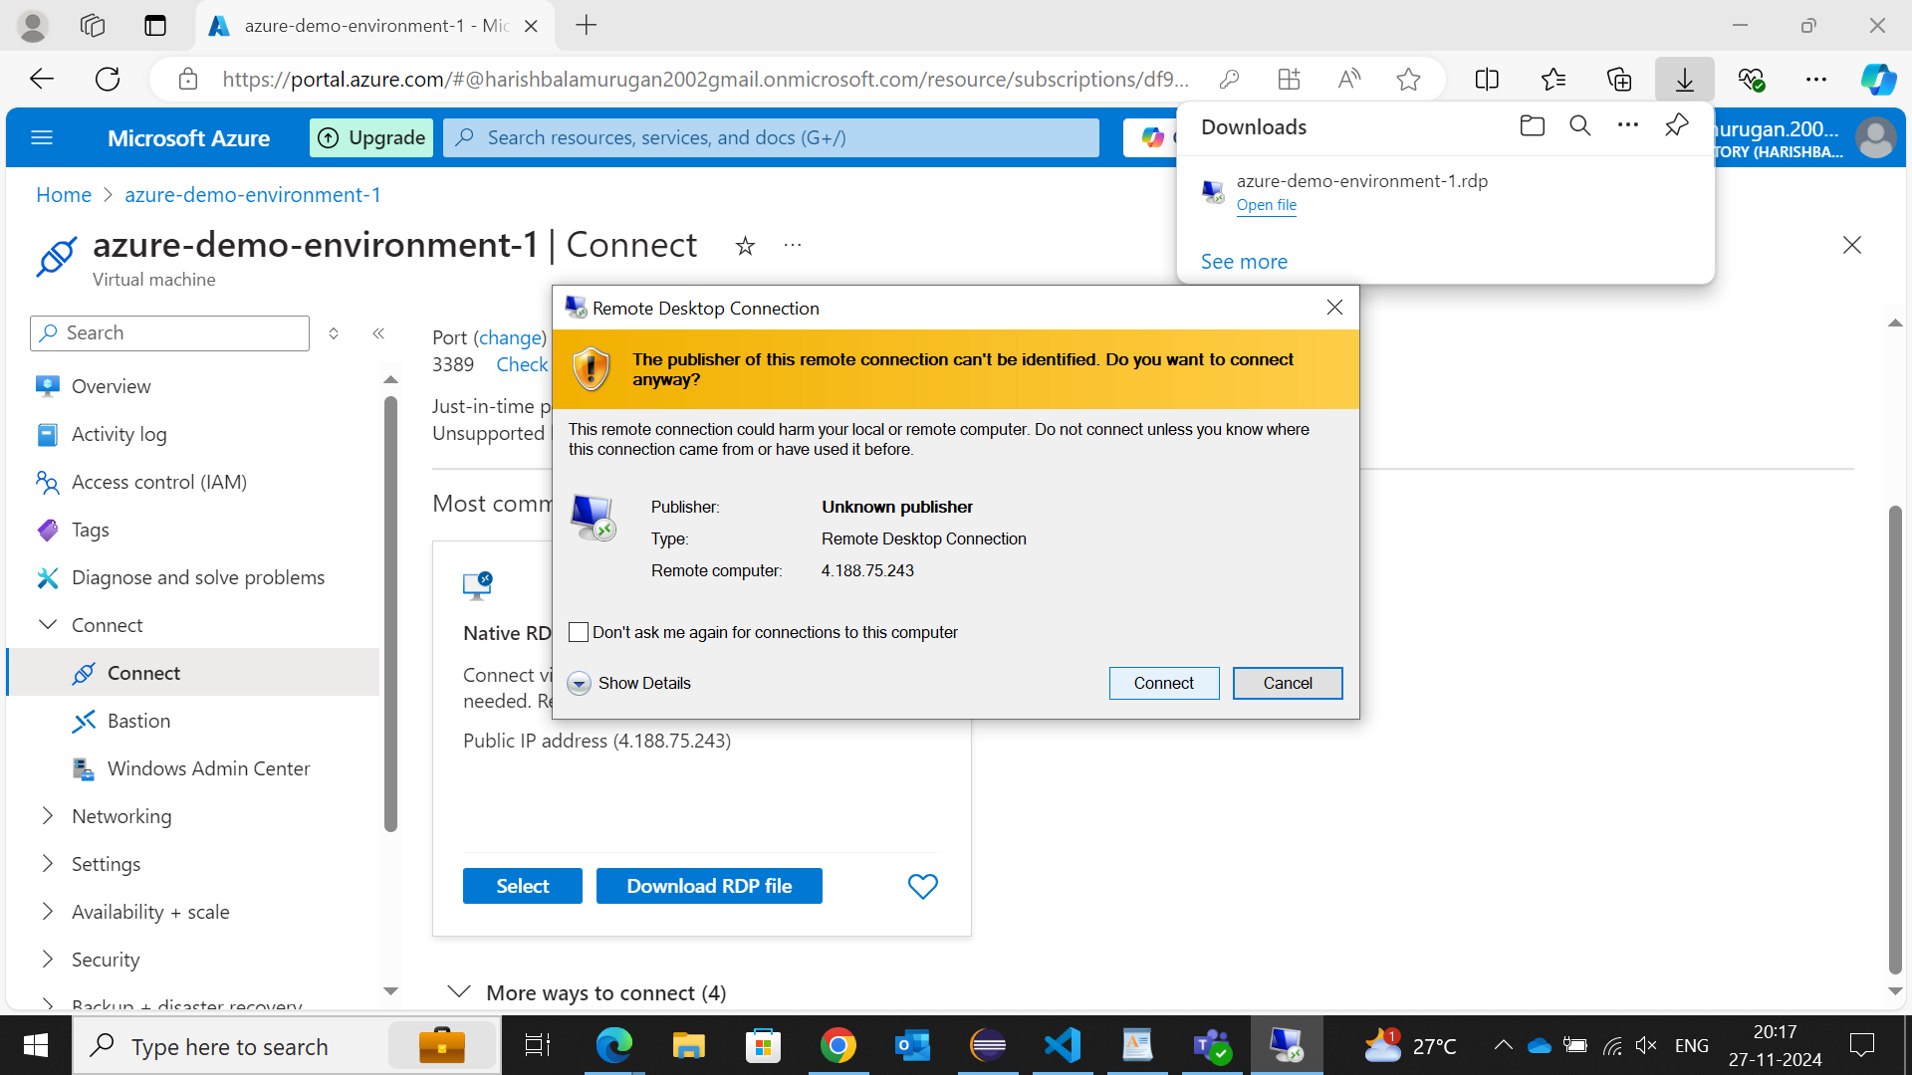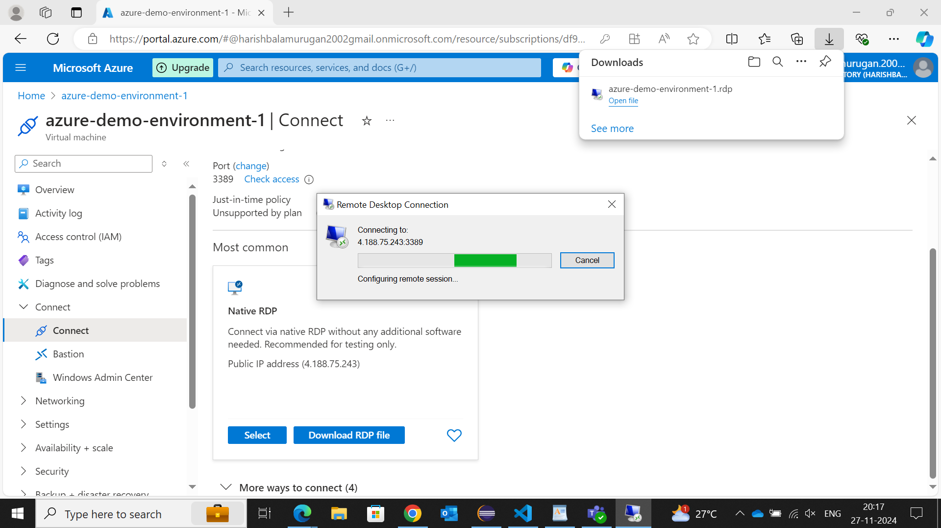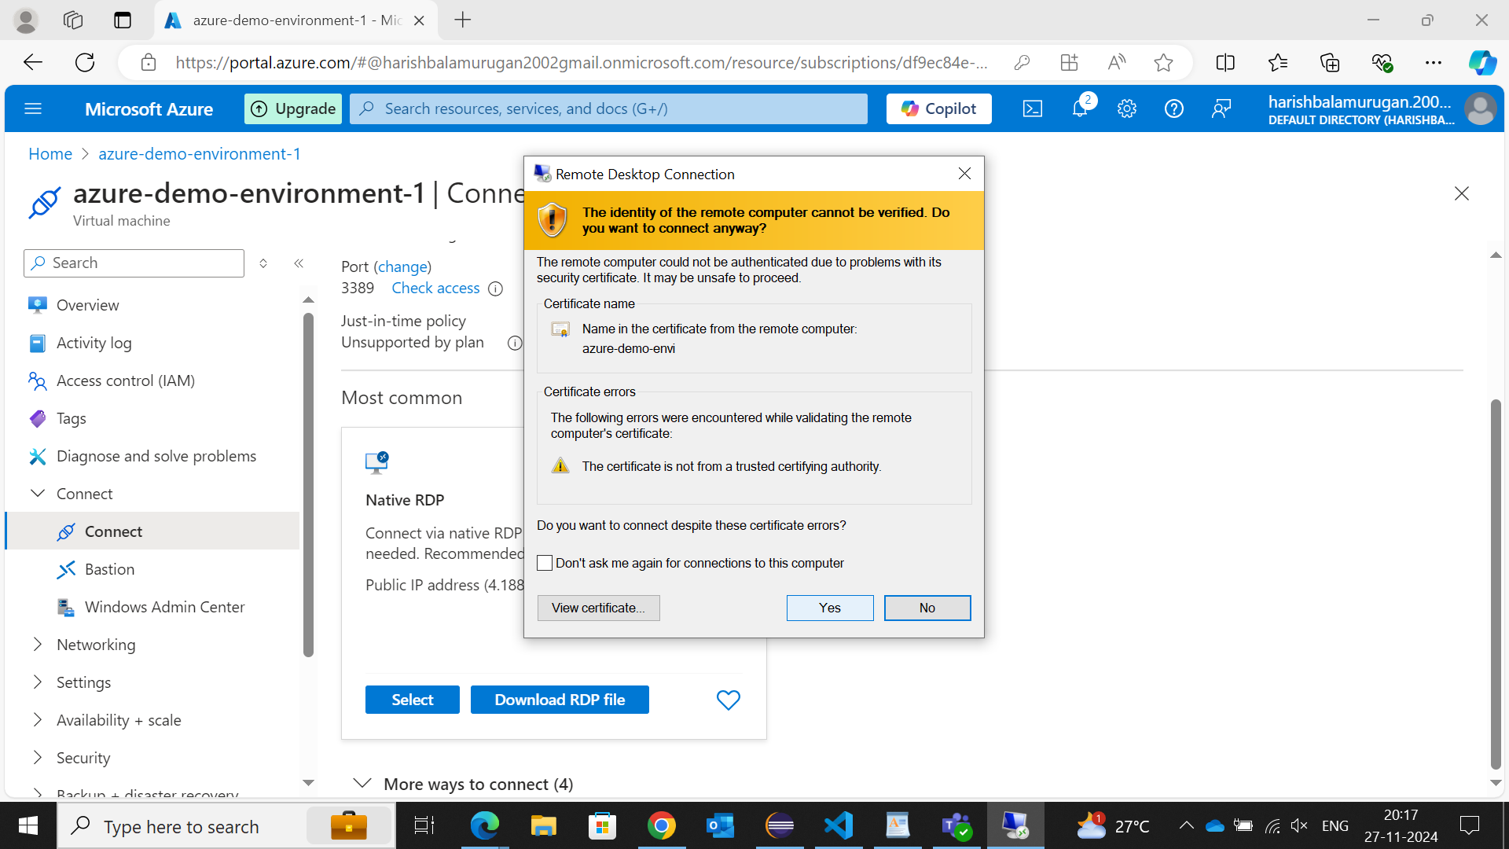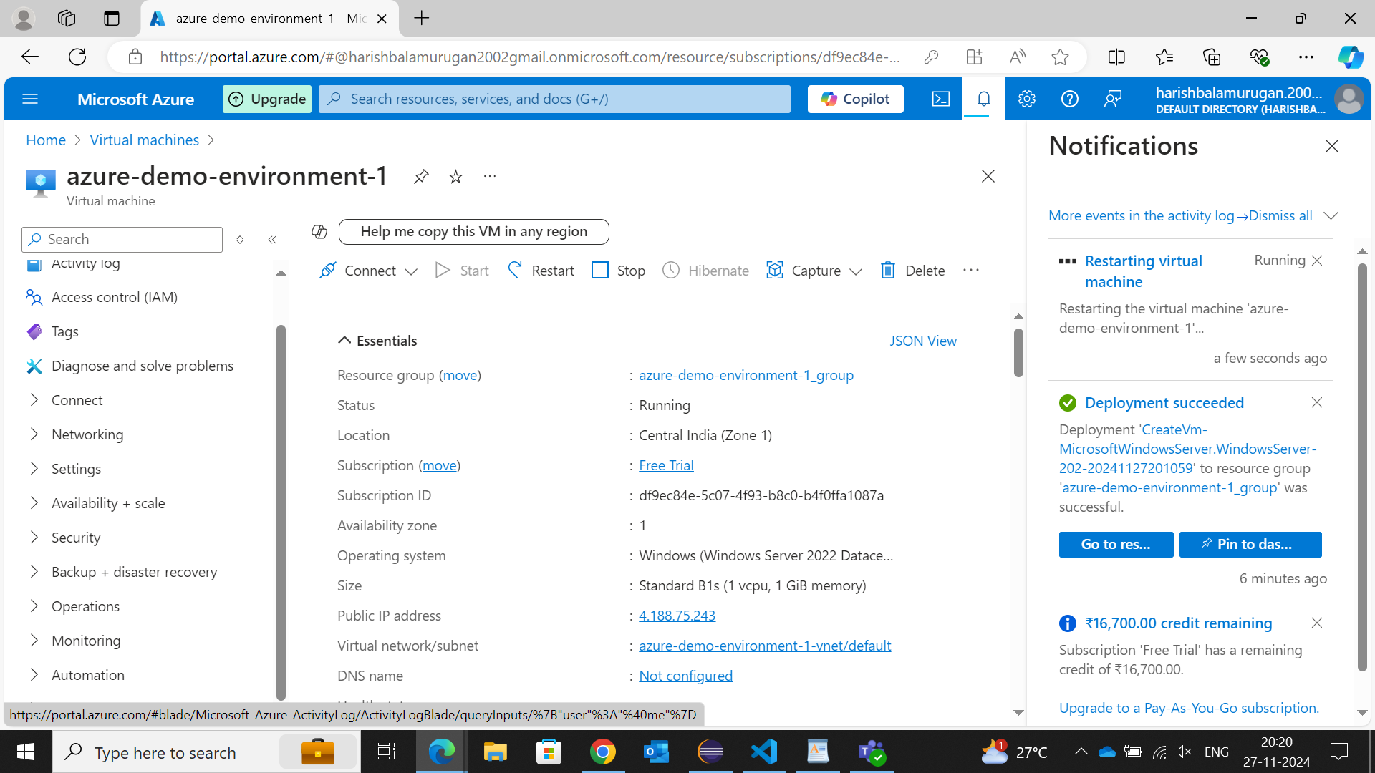

**Step 8: Deleting virtual machine.**

After running your VM, if not in use delete it or stop the connection that you’ve made.